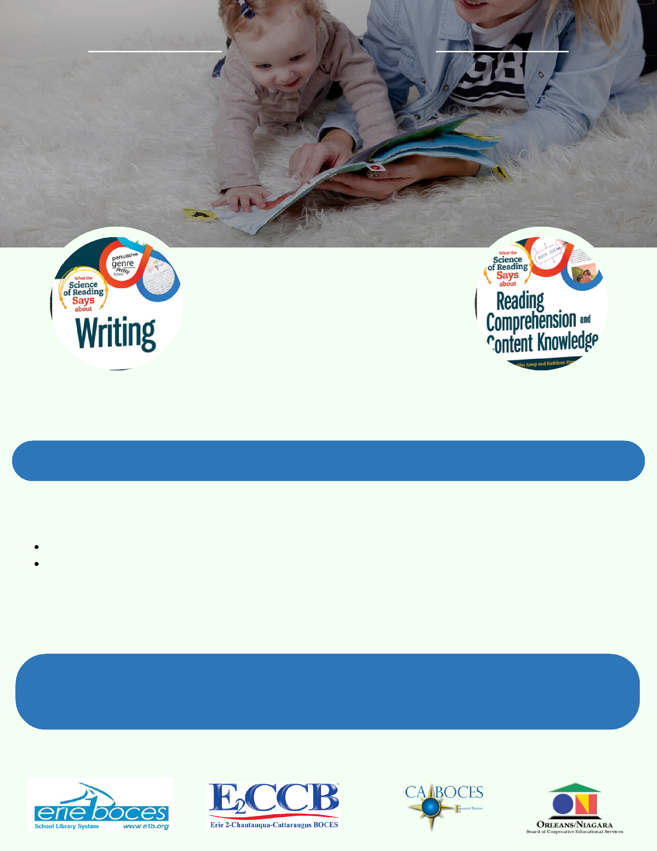**WNYSLS Book Study**

**Science of Reading**

***CTLE Credit Provided***

**BOOK STUDY SCHEDULE**

**Nov - Jan:**

Book Study 1 - 6 CTE Hours

**Feb - Apr:**

Book Study 2 - 6 CTE Hours

**May 21st:**

In Person Workshop at Erie 1

|  |  |  |
| --- | --- | --- |
| **WRITING** | BOCES - 5 CTE Hours | **READING COMPREHENSION &** |
|  |  | **CONTENT KNOWLEDGE** |

**The Science of Reading & NYS Literacy Briefs -**

**The Role of School Libraries**

The School Library System offices of the WNY Region are pleased to facilitate a study centered on The Science of Reading and the NYS Literacy Briefs for school libraries. Participants will receive copies of two books:

What the Science of Reading Says about Writing by Jennifer Jump & Hillary Wolfe

What the Science of Reading Says about Reading Comprehension and Content Knowledge by Jennifer Jump & Kathleen Kopp

There will be two book studies, facilitated online from November until April. The learning will culminate with an in-person workshop at the Erie 1 BOCES Campus: 355 Harlem Rd, West Seneca, NY 14224 on May 21st.

**Registration Closes October 10th - Link Below**

https://register.caboces.org

+123-456-7890